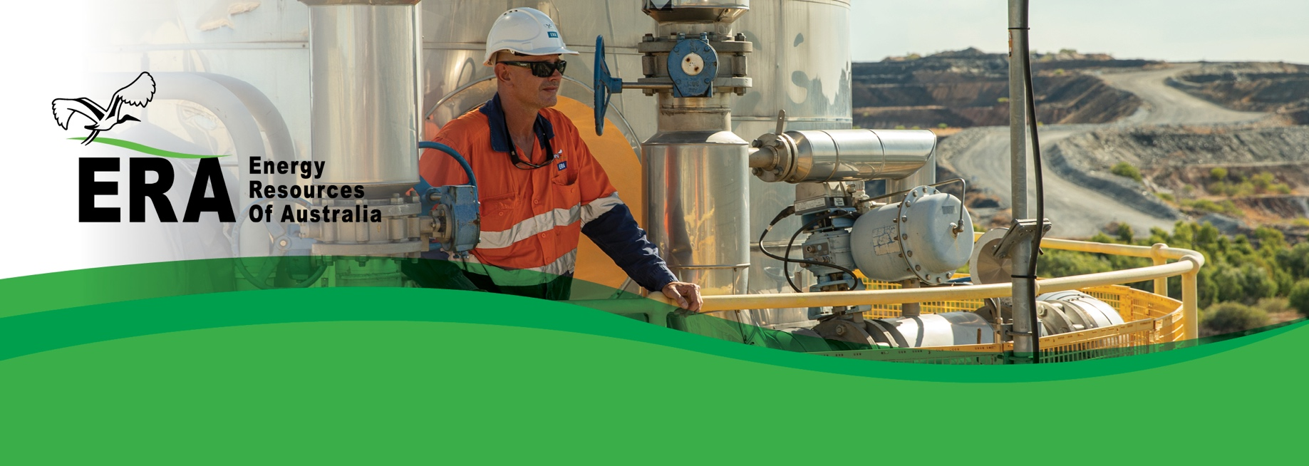ERA acknowledges that there is significant benefit and value to be gained by implementing effective asset management strategies at all levels across the business.

*Innovate and continuously improve*

ERA Asset Management Policy

Managing assets throughout their lifecycle is critical to achieving their utilisation targets and design function. By ensuring safe and reliable operation of our assets, we ensure we achieve our core value of protecting the health and safety of our employees and the nearby community, together with the protection of the surrounding environment.

Purpose

Effective asset management is fundamental to our goal of zero harm and ensures the ongoing reliability of our plant and equipment at the right cost.

Background

The objective of the company’s asset management program is to ensure assets are fit-for-purpose; installed and commissioned correctly; operated within their design parameters; and have the right maintenance done at the right time in the right way (including replacement) to ensure they continue to meet their required function. Moreover, the asset will continually deliver the value which is expected in terms of:

* Health, safety and environment.
* Process safety.
* Availability and reliability.
* Throughput.
* Integrity.
* Quality and cost.

Asset management is more than just maintenance. Successful asset management requires interdepartmental commitment that impacts at every level, from specifying and purchasing the right equipment in the first place, through to operations and maintenance, and ultimately to disposal.

The accountability for asset management applies to the entire business and a culture focused on asset management is essential for the delivery of Ranger Rehabilitation objectives.

ERA asset management commitments

As an organisation, we are committed to effectively managing our assets throughout their lifecycle to ensure that they:

* Operate when needed.
* Produce at their required capacity.
* Perform safely without harm to people or the environment.
* Meet the needs of the business.

To achieve this, the Company will:

* Adhere to and maintain asset management strategies, standards and procedures.
* Ensure that the design, maintenance and operation of assets comply with all relevant codes and standards.
* Ensure assets are fit for purpose when we buy or build them.
* Ensure any changes to plant and equipment is properly managed.
* Operate plant and equipment within design parameters.
* Maintain assets throughout their lifecycle ensuring the right work is done the right way at the right time.
* Effectively control risks involving catastrophic failure or widespread underperformance of critical assets.
* Educate and train the workforce in asset management to ensure a skilled and competent workforce.
* Effectively utilise, maintain and improve the site’s computerised maintenance management system.
* Establish measurable targets and consistently review metrics to optimise asset integrity and reliability.
* Perform efficient and effective quality assurance and control, including reliability and defect elimination functions.
* Replace or retire assets at the end of their economic life.
* Ensure that this policy is reviewed and updated periodically.

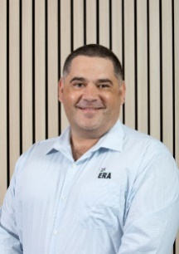

**Brad Welsh**   
Chief Executive