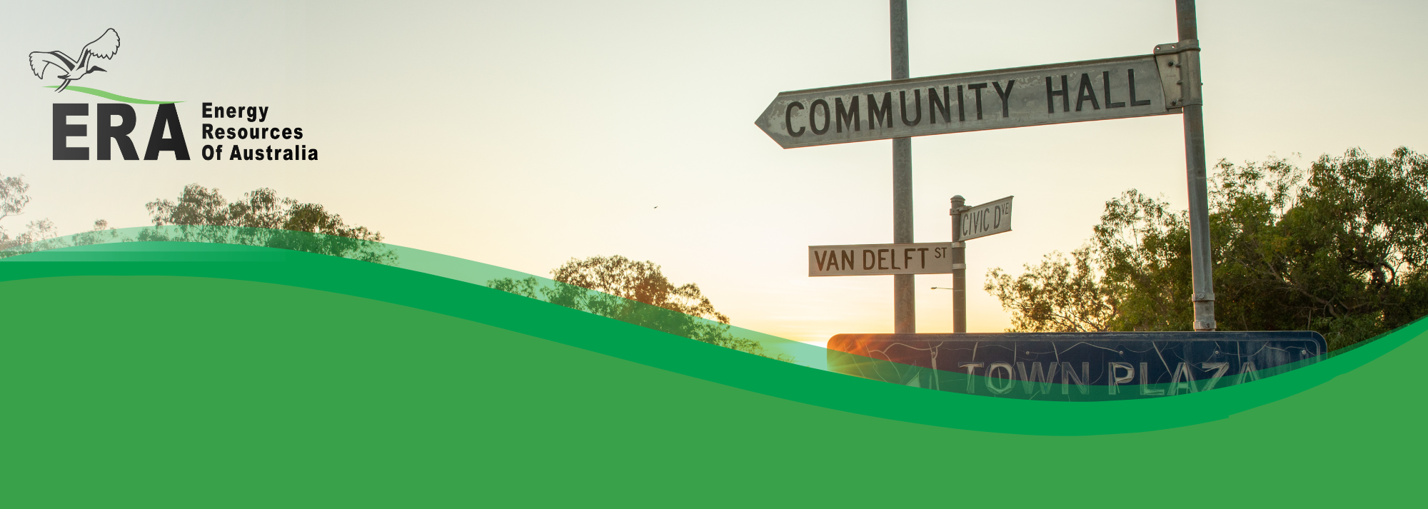Energy Resources of Australia Ltd (ERA) acknowledges that the Mirarr people have been the custodians of the Mirarr estate for over 50,000 years. This includes the Ranger Project Area, the Jabiluka Mineral lease and the township of Jabiru.

ERA Communities policy

*Supporting the community*

ERA’s vision is to create a positive legacy and achieve sustainable, world class rehabilitation of former mine assets. ERA will deliver this vision by partnering with Mirarr Traditional Owners, governments and other key stakeholders.

One of ERA’s core values is being a trusted part of the community and the region in which we operate. ERA acknowledges that good community relations are as necessary for our business success as the effective management of our operations.

Our goal is to understand and manage the social, environmental and economic implications of our activities. We earn the respect of partners and stakeholders, and always seek shared value.

It is for these reasons that ERA is committed to:

* Honoring our obligations and commitments.
* Exemplary environmental and cultural heritage management.
* Open and transparent communication and engagement.
* Sustainable community development, events and partnerships.

Employees and contractors have a responsibility to:

* Conduct themselves in accordance with Rio Tinto’s The Way We Work, ERA’s business code of conduct and our accommodation code of conduct.
* Complete ERA’s cultural awareness training.
* Follow all company policies and procedures.
* Report all incidents and concerns, however minor, immediately.

To achieve this the company will:

* Comply with all applicable legislation and other commitments.
* Comply with all agreements with the Northern Land Council and Traditional owners.
* Manage our Closure activities in accordance with Rio Tinto’s Communities and Social Performance framework.
* Manage our Closure activities in accordance with ERA’s Cultural Heritage Management Plan.
* Undertake regular analysis of the potential social, cultural, reputational, economic and environmental risks within our business.
* Ensure effective controls are in place to mitigate and manage identified risks.
* Ensure that accountabilities for community and social performance management are part of day-to-day work of team members and that they have the resources, development and training to meet these accountabilities.
* Build and maintain supportive and respectful relationships with all our stakeholders through open and transparent communication and engagement, respecting their culture, diversity and considering their interest in the Company’s management decisions.
* Invest in community partnerships, initiatives and programs that support a sustainable region and deliver mutual value for our business and our stakeholders.
* Support regional economic development in partnership with government, non-government and local organisations; this includes the areas of health, employment skills training, environment and culture.
* Contribute to supporting local organisations and events.
* Establish measurable objectives and targets to continuously improve our communities and social performance.
* Communicate this policy to all persons working for, or on behalf of ERA and stakeholders, and ensure that all employees understand and comply with this policy.
* Ensure this policy is reviewed and updated periodically.

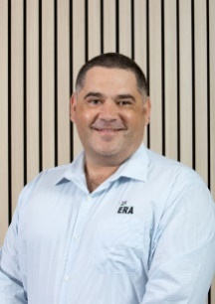

**Brad Welsh**   
Chief Executive