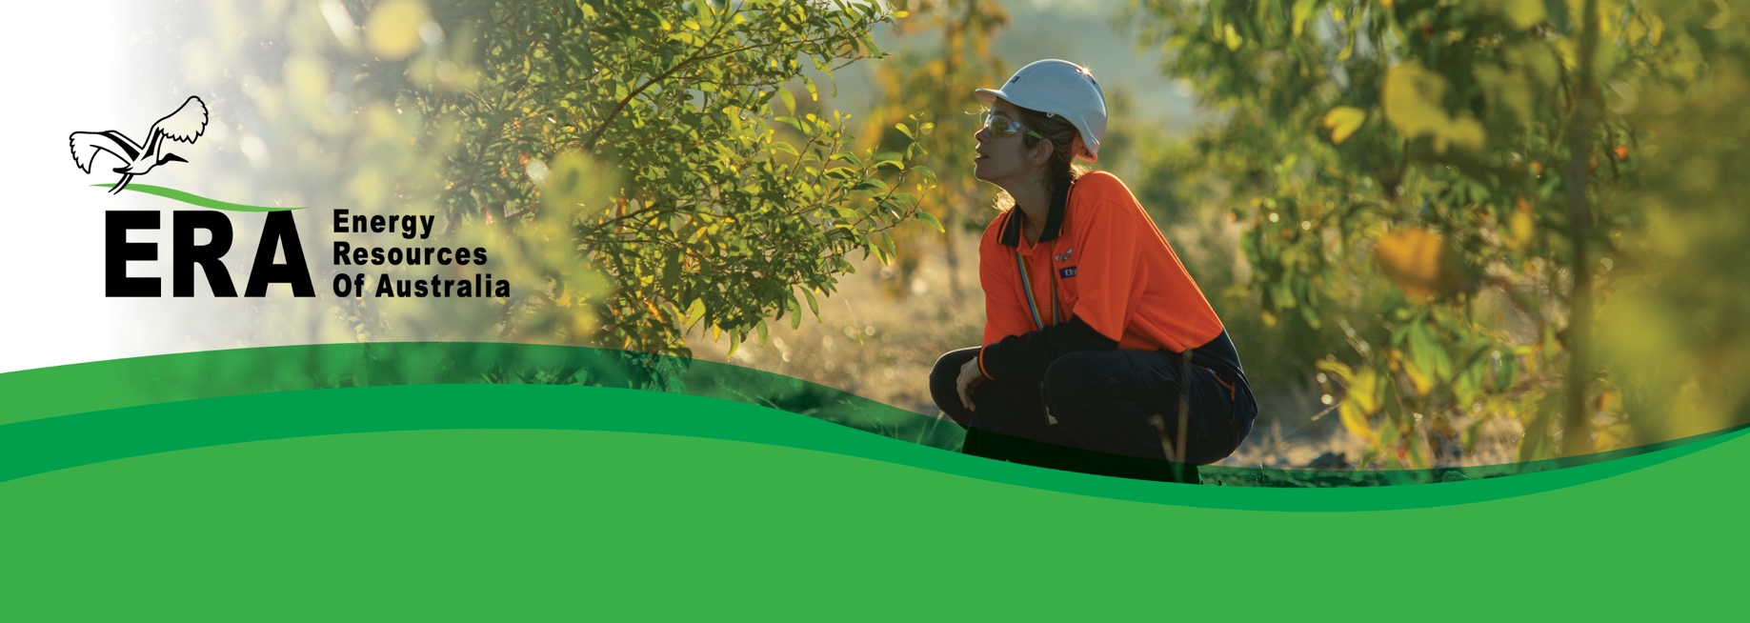ERA is setting the standard for mine site rehabilitation in a culturally and environmentally sensitive region. In doing so, ERA looks to protect the natural and cultural values of the surrounding World Heritage-listed Kakadu National Park. To proudly restore the landscape for those who will walk after us.

*Ensure the environment remains protected*

ERA Environmental policy

Our goal during the rehabilitation of Ranger is to create a physical, ecological and cultural landscape that meets the expectations of the Mirarr Traditional Owners. Effective and safe management of our environmental risks and impacts is an essential part of our care for future generations.

Employees and contractors have an individual responsibility to ensure that environmental harm resulting from our activities is minimised and ERA expects them to:

* Consider the potential impacts to the environment in all that they do.
* Conduct a risk assessment for all activities that have the potential to cause environmental harm.
* Implement to the best of their ability all measures designed to mitigate environmental harm and prevent incidents that may result in environmental damage or pollution.
* Follow all environmental rules and procedures.
* Report all incidents and concerns, however minor, immediately.

To achieve this the Company will:

* Maintain and continuously improve the Environmental Management System that is externally audited and certified to ISO14001:2015.
* Establish measurable objectives and targets to sustain environmental performance improvements.
* Continuously improve our environmental management performance.
* Maintain a risk-based approach to the identification

and management of hazards and opportunities.

* Acknowledge and respect Indigenous and local communities’ connections to lands, waters and the environment.
* Establish and maintain programs to minimise emissions and appropriately manage the disposal of waste.
* Ensure surrounding waterways remain protected via exemplary water management and monitoring.
* Respect all agreements with the Northern Land Council and Aboriginal Traditional Owners.
* Comply with, and endeavor to exceed, all applicable legislation and other commitments.
* Ensure that environmental accountabilities are part of the day-to-day work of team members and that they have the resources, development and training to carry them out.
* Communicate this policy to all persons working for, or on behalf of ERA, external stakeholders and the wider community, and ensure all personnel understand and comply with this policy.
* Rehabilitate land on which ERA operates to be world class so as to establish an environment similar to the adjacent areas of Kakadu National Park.
* Conduct research to develop environmentally sound closure strategies.
* Support environmental management improvements by contributing to the mining and scientific community through public and internal dissemination of research findings.
* Ensure sound environmental decision making through collaboration with leading research providers, using best practice technologies and engaging qualified suppliers.
* Respect and adhere to the Rio Tinto global standard of conduct outlined in The Way We Work.
* Strive to meet Traditional Owners, Stakeholder’s and the local community expectations.
* Ensure that this policy is reviewed periodically.

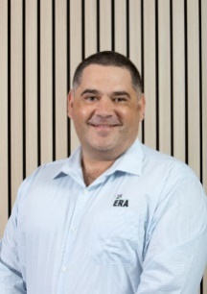

**Brad Welsh**   
Chief Executive