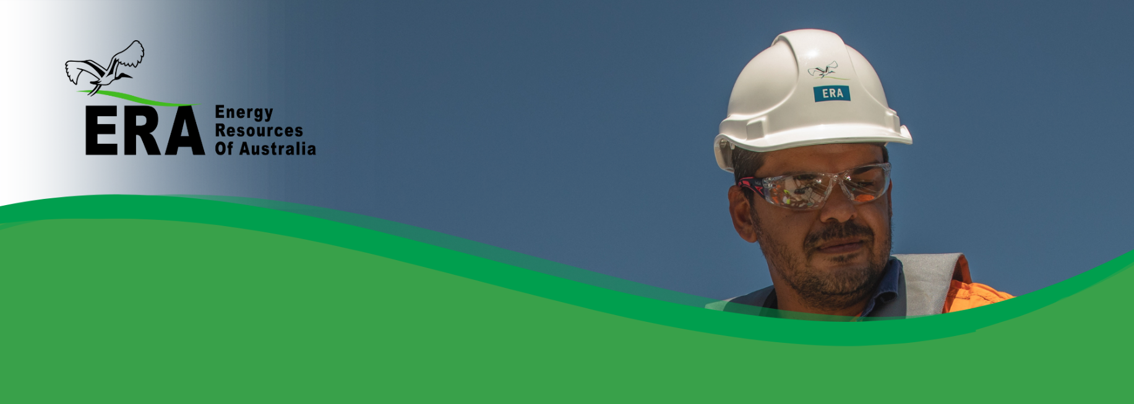One of ERA’s core values is maintaining the safety and wellbeing of our people. By working together, we believe that all injuries, incidents and occupational illnesses can be prevented, and everyone shall go home safe and healthy each day.

ERA health & safety policy

*Safety is our most important value*

No work is so important that you should endanger your health or safety to do it. Our goal is to ensure that no one comes to any harm while working for ERA on the Ranger Rehabilitation Project.

Employees and contractors have an individual responsibility to work safely, and ERA expects them to:

* Come to work in a fit and healthy state.
* Participate in hazard identification and control processes (JHA development & risk assessment) and not to start work until controls have been implemented.
* Participate in Critical Risk Management (CRM) through completion of verifications on jobs that have a fatality risk.
* Comply with ERA’s Cardinal Rules, Safety and Health Procedures.
* Look out for, and help, fellow team members at all times and stop a job if it becomes unsafe.
* Wear all personal protective equipment as prescribed or identified.
* Report all incidents and concerns, however minor, immediately.

## To achieve this, the Company will:

* Invest in planning to go home safely each day.
* Maintain the Critical Risk Management (CRM) system to ensure all critical risk controls are being verified.
* Establish measurable objectives and targets against our risk management framework.
* Continuously review and improve our safety and health performance and ensure risks are identified and managed.
* Comply with, and aim to exceed, all relevant legislation and other commitments, including the Rio Tinto Safety, Management System and Occupational Health Standards.
* Ensure that health and safety accountabilities are part of the day-to-day work of team members and that they have the resources, development and training to fulfill them.
* Communicate this policy to all persons working for, or on behalf of ERA, external stakeholders and the wider community, and ensure all personnel understand and comply with this policy.
* Authorise all personnel to stop any work process if concerned about the safety of themselves or others.
* Always strive to achieve our goal of zero harm by working to prevent incidents that may result in injuries and illnesses, security threats or property damage.
* Provide equipment and work plans that meet all relevant standards.
* Report and investigate all injuries/ illnesses, incidents and non-conformances to determine causes and implement actions in order to prevent a recurrence.
* Provide early intervention following an injury and/or illness to improve recovery and achieve a timely return to the workplace.
* Not ignore any breach of safety or health standards or standard operating procedures.
* Encourage employee and contractor consultation and participation, provide recognition for personal contribution, and promote the importance of safety and health away from work.
* Promote and support leaders to motivate, coach and champion positive health and safety behaviours for all personnel.
* Respect and adhere to the Rio Tinto global standard of conduct outlined in The Way We Work.
* Ensure that this policy is reviewed periodically.
* Undertake regular monitoring and assessment of the Health and Safety Management system to ensure continual improvements are identified and documented.

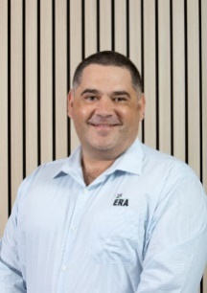

**Brad Welsh**   
Chief Executive