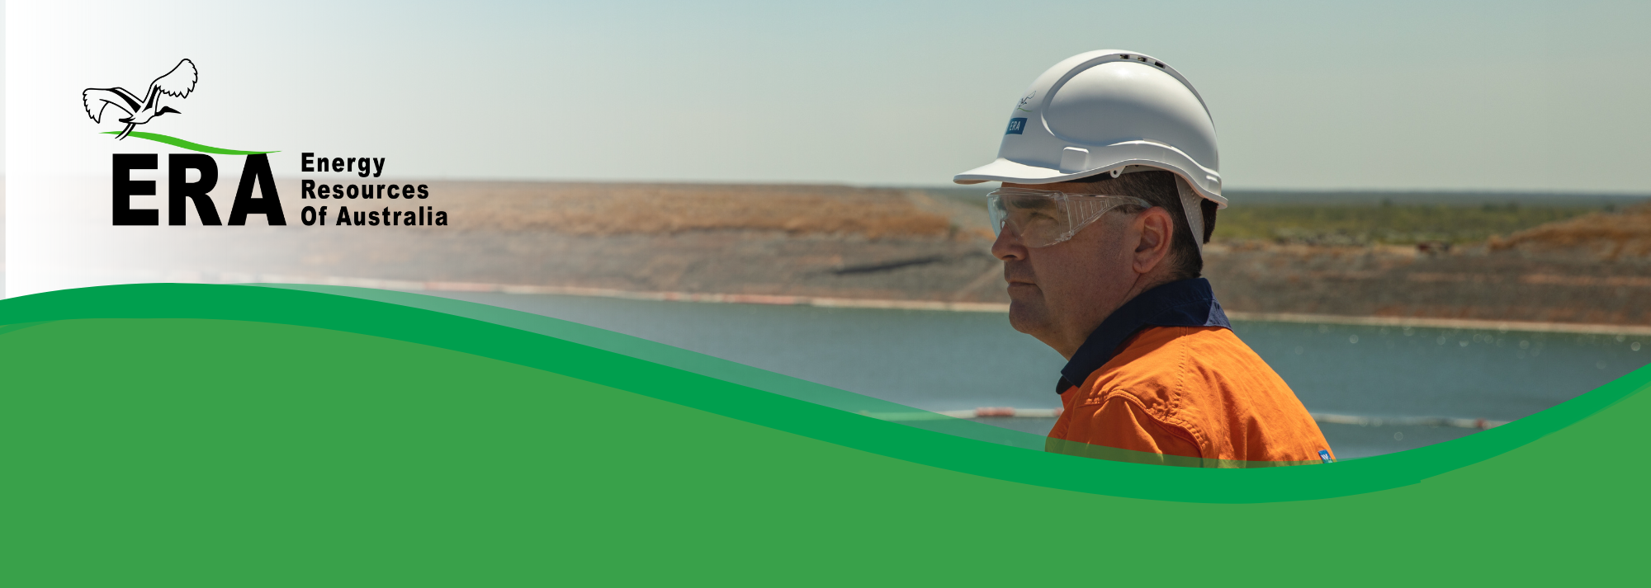ERA’s core value is the protection of the health and safety of our workers and the nearby community, together with the protection of the surrounding environment.

ERA Process Safety Policy

*Stop work & speak out when there is a risk*

Our goal is to manage process safety at our rehabilitation project by ensuring that controls are both functional and effective at preventing and mitigating the impacts of high consequence, low probability process safety events.

Purpose:

ERA recognises that process safety events have the potential to significantly impact the health and safety of our workers, the community, and the surrounding environment, as well as causing property and reputation damage, and business interruption.

Understanding and managing process safety hazards is essential to improving our performance and protecting our environment.

It is for these reasons that ERA is committed to:

* Understanding and managing the identified hazards.
* Ensuring that critical controls are in place and effective at preventing and mitigating the effects of process safety events.
* Designing, constructing, operating, and maintaining process safety relevant plant and equipment to recognised standards.
* Continually improving the workforce culture and learnings from process safety events to improve the management of process safety hazards.
* Maintaining a governance program that provides oversight and assurance of the process safety management system.

All personnel have a responsibility to:

* Be aware of and understand process safety hazards.
* Establish, maintain and monitor, to the best of their ability, critical controls to prevent process safety incidents from occurring and to mitigate the impacts of any process safety events.
* Recognise and report process safety events.

To achieve this, the Company will:

* Maintain an effective system to manage process safety that includes periodically reviewing and adhering to a process safety standard.
* Establish measurable objectives and targets to continuously improve our process safety performance.
* Undertake regular analysis of process safety hazards that exist within closure activities.
* Utilise a three lines of defence approach to ensure that controls are implemented and effective to prevent a process safety event and report on the health of these controls.
* Ensure that accountabilities for process safety management in projects are understood by all personnel and that they have the resources, development, and training to meet these accountabilities.
* Educate and train our workforce in process safety management, including how they contribute to process safety control and to recognise and report process safety events.
* Ensure changes that impact process safety are effectively managed.
* Operate and maintain our facilities, to the best of our abilities to ensure that the risk of occurrence or impacts of process safety hazards are as low as reasonably practicable.
* Properly manage changes to plant, processes and people.
* Review and incorporate learnings from industry and participate in industry forums to improve performance at our operation.
* Communicate this policy to all persons working for, or on behalf of ERA and external stakeholders, and ensure that all employees understand and comply with this policy.
* Ensure that this policy is reviewed and updated periodically.

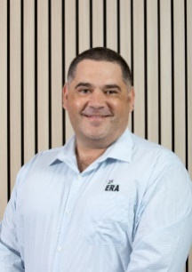

**Brad Welsh**   
Chief Executive