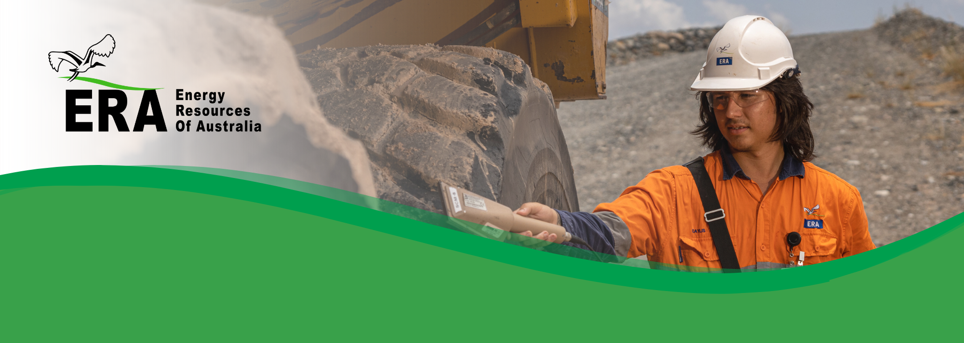ERA has core values relating to the safety and wellbeing of its workers and the protection of the environment. Radiation safety and protection are included in these core values.

ERA radiation policy

*World-class radiation safety & protection*

Our goal is to ensure that radiation exposure to workers, the public and the environment are as low as reasonably achievable (ALARA).

Purpose:

* Manage the radiation exposure of individuals in the workforce, the general public and the surrounding environment.
* Continuously improve our radiation management system and implement leading practices in radiation protection, in accordance with the ALARA principle as part of our commitment to minimise doses.
* Comply with, and where practical, endeavor to exceed all applicable legislation.

Workers who have the potential to be exposed to radiation or perform duties which may affect the radiation exposure of others have individual responsibilities. ERA expects them to:

* Follow radiation protection and waste management practices.
* Participate in radiation safety training programs.
* Use all equipment supplied for radiation protection and monitoring.
* Not engage in any careless or reckless action that might result in unnecessary radiation exposure to themselves or others, or compromise the management of radioactive waste.
* Report any defects in equipment or procedures that may compromise radiation protection or the management of radioactive waste.
* Report all incidents or accidents.
* Advise of any previous employment involving occupational exposure to radiation.
* Follow procedures for cleaning and clearance of equipment prior to removal off site.

To achieve this, the Company will:

* Maintain an effective radiation management system and review regularly.
* Maintain strict control over radiation hazards.
* Comply with and, where practical, endeavour to exceed all applicable legislation, codes of practice and Rio Tinto standards.
* Communicate this policy and other radiation safety information.
* Employ radiation safety personnel and have access to an experienced and qualified Radiation Safety Officer (RSO).
* Conduct regular training in radiation safety.
* Report and investigate all radiation related incidents.
* Adhere to “The Way We Work”.
* Ensure that this policy is reviewed periodically.

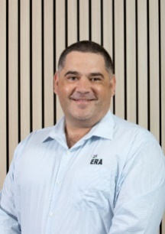

**Brad Welsh**   
Chief Executive